**Wind Energy Conversion Systems**

**Assignment 3**

**M.Shamaas**

**ID # 2018-MS-EE-4**

**Introduction**

This case study investigates the dynamic performance of a 2.45 MW, 4000 V, 53.33 Hz, 400 rpm non-salient pole permanent magnet synchronous generator standalone wind energy system. The generator is loaded with a three-phase balanced resistive load RL and operates at 320 rpm (0.8 pu) at a given wind speed. The loading of the generator can be changed by a switch. When the switch is closed, the load resistance is reduced to RL/2 per phase.

The dq-axis model of the induction generator can be obtained by decomposing the voltage, current and flux linkage space-vectors into their corresponding d- and q-axis components.

The PMSG is modeled in the rotor field synchronous reference frame. The synchronous reference frame is derived from dq-axis rotating reference frame by putting θ = :

Similarly, the two-phase to three-phase transformation in the stationary reference frame, known as αβ/abc transformation, can be performed by:

**Part 1: Analysis of Synchronous Generator in Standalone Operation**

The PMSG is loaded with a three-phase balanced resistive load RL and operates at 320 rpm (0.8 pu) at a given wind speed. The loading of the generator can be changed by a switch. When S is closed, the load resistance is reduced to RL/2 per phase. It is assumed that the combined moment of inertia of the blades, rotor hub, and generator are very large such that the rotor speed is kept constant at 320 rpm during the transients caused by the changes in load resistance. Since the rotor speed wr is known, it becomes the system input variable.

SCIG dq-axis Reference Frame Model Equations

1. Flux Linkage Equations:
2. Voltage Equations
3. Torque Equation

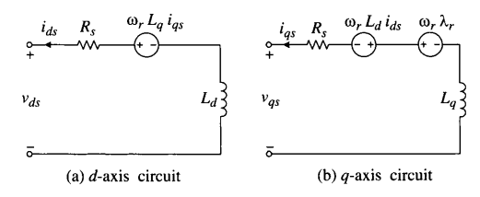

PMSG Machine Constants

1. Rated Line-Line Voltage
2. Rated Stator Current
3. Base Impedance
4. Number of Pole Pairs
5. Rated Stator Frequency
6. Stator Winding Resistance
7. D-axis Inductance
8. Q-axis Inductance
9. Rated Rotor Flux Linkage
10. Rotor Speed
11. Load Resistance
12. Rated Mechanical Torque

Initial Conditions (t = 0-)

In this case, the PMSG model in the synchronous reference frame was used, which was realized by setting the speed of the arbitrary reference frame (w = ).

1. The reference frame is synchronous
2. Electrical Frequency
3. Rotor Speed
4. Stator Currents

Simulink Model

The input variables of the model include the dq-axis stator voltages vds and vqs, rotor voltages vdr and vqr, the mechanical torque Tm, and the speed of the arbitrary reference frame w. The output variables are dq-axis stator currents, ids and iqs, the electromagnetic torque Te, and the mechanical speed wm of the generator.

1. Block diagram for dynamic simulation of PMSG for standalone operation.

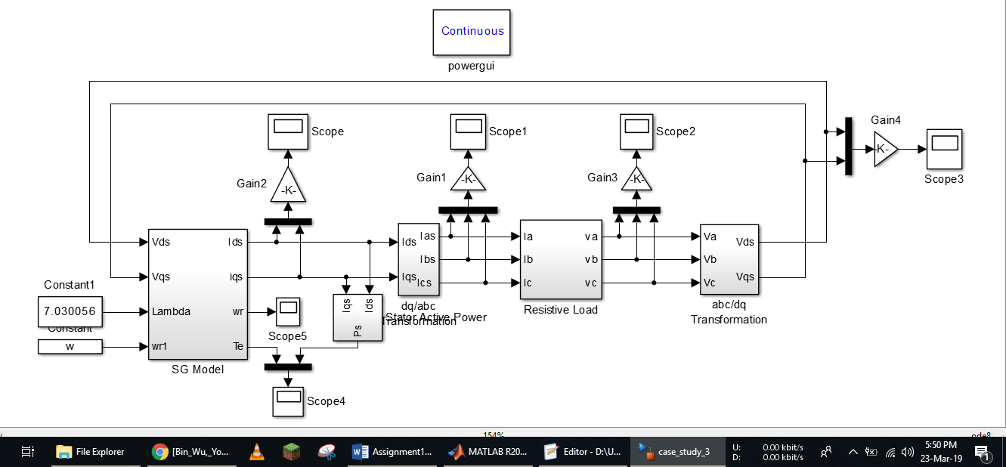

1. PMSG System

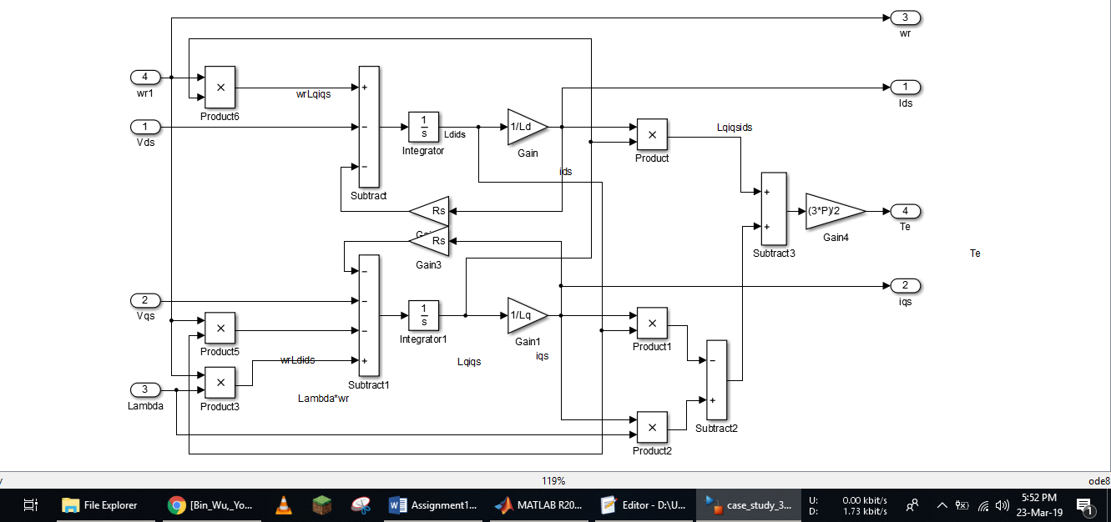

1. Block diagram for Three Phase Resistive Load controlled with ideal switches.

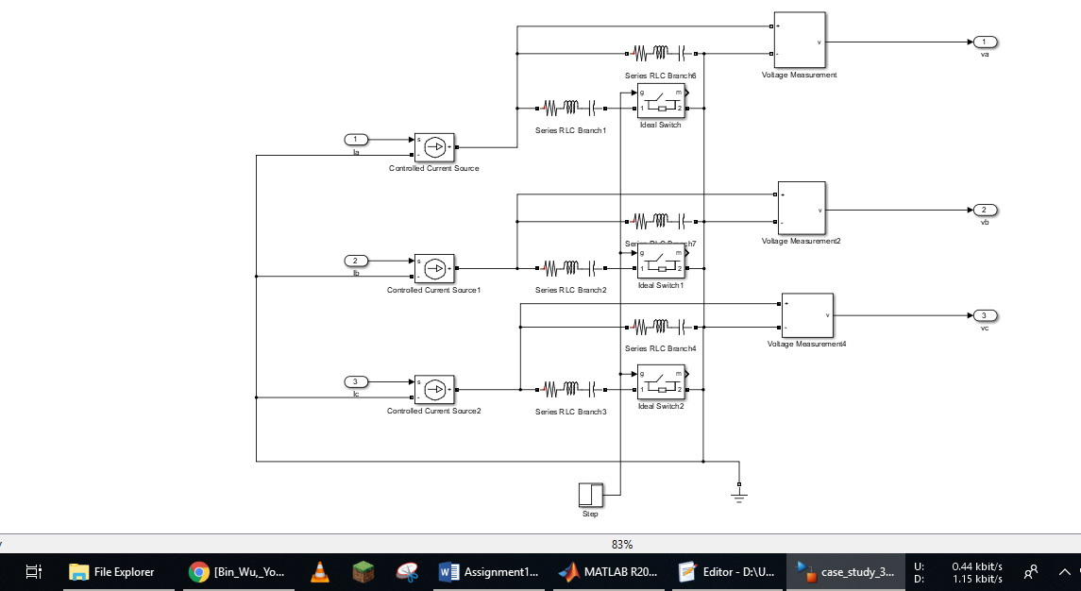

1. Reference Frame Transformations

Assuming a three-phase balanced grid, the grid voltages vas, vbs, and vcs in the stationary frame are transformed to the two-phase voltages vd and vq in the dq synchronous frame through the abc/dq transformation. The simulated dq-axis stator currents ids and iqs are also in the synchronous frame, which are transformed to the three-phase currents ias, ibs, and ics by the dq/abc transformation. The three-phase stator voltages are transformed to the two-phase voltages via the abc/dq transformation and the calculated two-phase stator currents are transformed back to the three-phase stator currents via the dq/abc transformation.

abc/dq Transformation

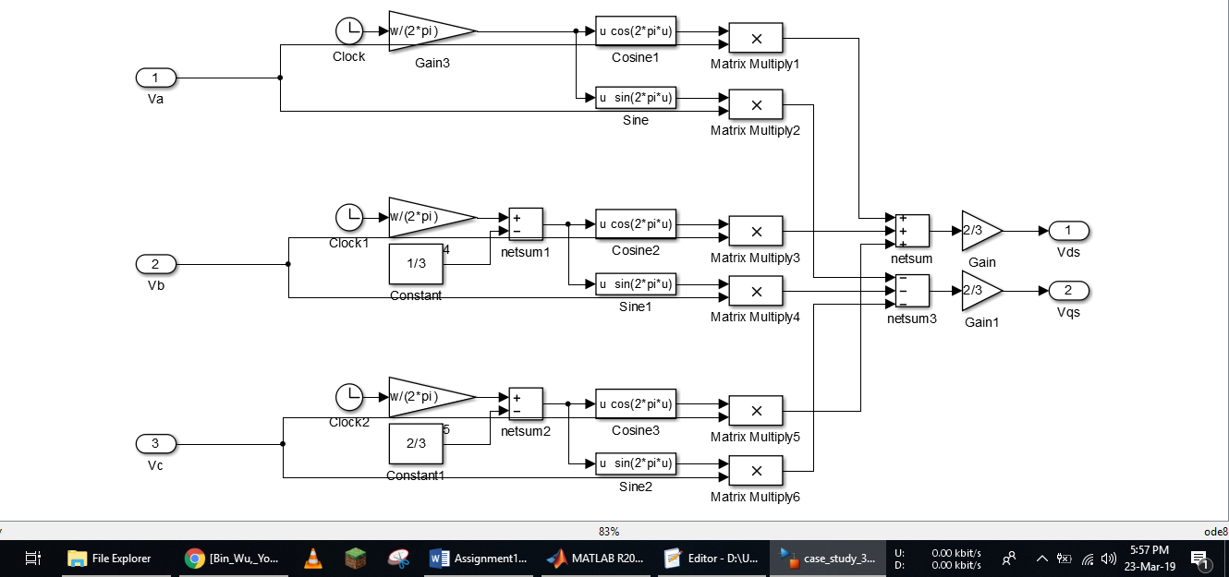

dq/abc Transformation

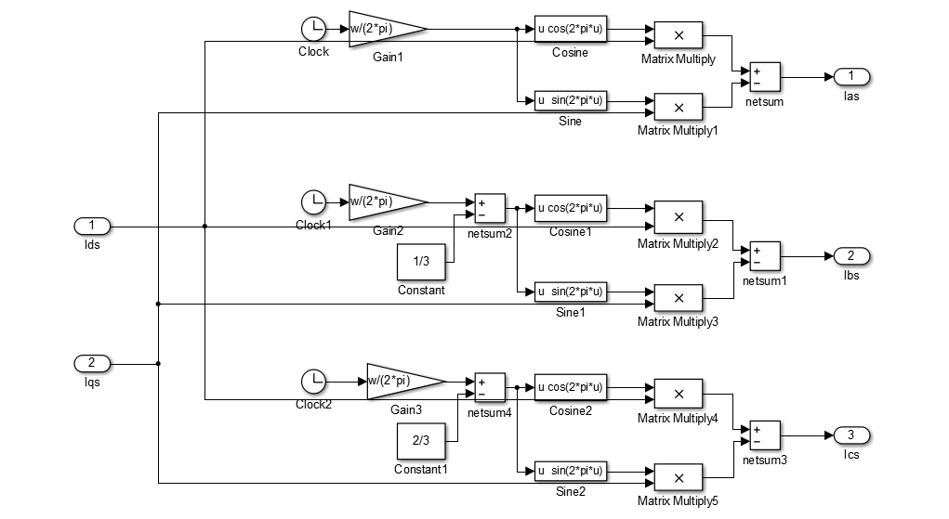

1. synch2.m

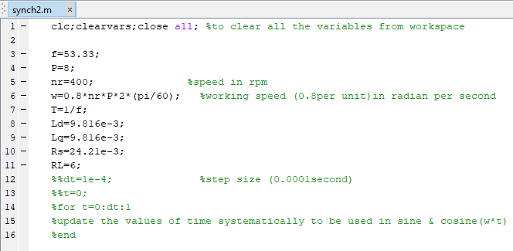

Results

1. Currents (ias, ibs, ics)

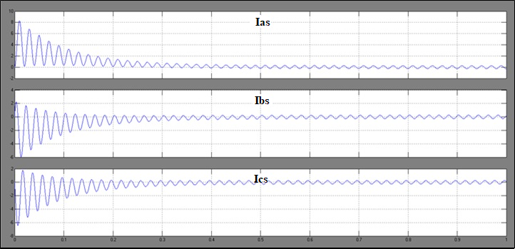

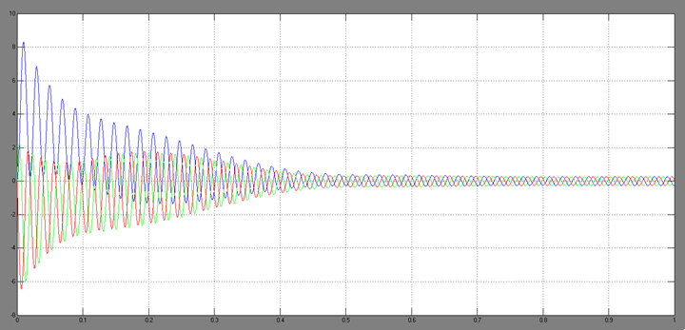

1. Electromagnetic Torque

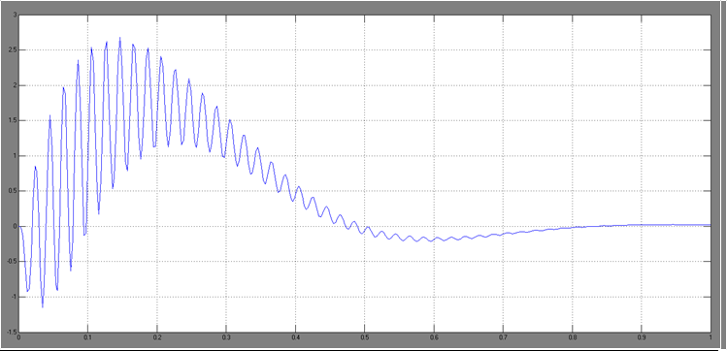

1. Rotor Mechanical Speed

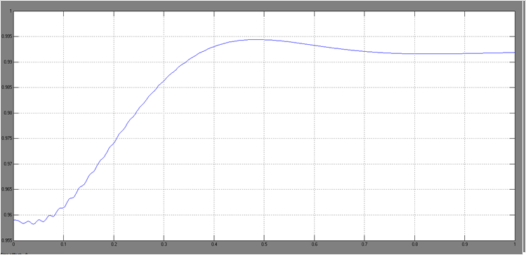

During the system transients, a high inrush current flows into the generator and a DC offset current appears in each of the stator currents ias, ibs, and ics, but the sum of these offset currents is zero due to a three-phase balanced system. As a rotating magnetic field is being built and generator core is being magnetized by the stator current, an electromagnetic torque Te is produced. Since the generator operates below synchronous speed in motoring mode, it produces a positive torque that accelerates the turbine. The generator finally reaches the synchronous speed of 1500 rpm (0.992 pu) at t = 0.84 sec, at which it enters the steady-state operation with Te= Tm = 0. The direct connection of the generator to the grid during the system start-up causes excessive inrush currents with peak values of 8.3 per unit (pu), high electromagnetic torque (2.7 pu, peak), as well as high torque oscillations. It can be concluded that the direct grid connection of the SCIG during the system startup cannot be used in practice, especially for the large megawatt turbines.